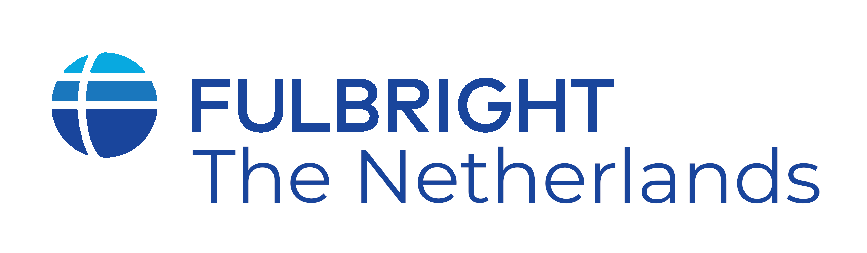

Name of grantee :____________________________________________________

1. Home address in the Netherlands during grant period
Street :_______________________________________________________
Postal code & city :_______________________________________________________
Telephone :_______________________________________________________
E-mail :_______________________________________________________

2. Contact person in the US during grant period (in case of emergency)
Name :_______________________________________________________
Street :_______________________________________________________
Postal code & city :_______________________________________________________
Telephone :_______________________________________________________
E-mail :_______________________________________________________

3. Partner information (only when partner also stays in the Netherlands)
Name :_______________________________________________________

4. Banking
Dutch bank account number (IBAN):___________________________________________
Name of Dutch bank:________________________________________________________

5. Information Sessions/Selection Panels/Other
If we need volunteers for information sessions, selection panels or other events, would you be interested in participating? Yes No
Would you be interested in a classroom visit? Yes No

6. Name and address of host school/university
Name :_______________________________________________________
Street :_______________________________________________________
Postal code & city :_______________________________________________________
Telephone :_______________________________________________________
E-mail :_______________________________________________________

7. Medical data
This information will only be used in case of an emergency. If you do not know your blood type or if you do not have a doctor either in the USA or Netherlands, just leave the spaces blank.
Blood type :_______________________________________________________
Family doctor in USA :_______________________________________________________
USA Doctor’s
contact information :_______________________________________________________
Family doctor in NL :_______________________________________________________ Medical conditions* :_______________________________________________________

* Information which we should know about in case of an emergency, such as diabetes or epilepsy.

7. Social Media
During your program, at events, photographs or video recordings or other materials may be taken/produced in connection with your participation in the program. Please indicate below whether we have your consent to use these materials if you are featured in them Yes No

